# Compass - Test Claim - Calculating Quantity of Packaged Medication General Information

Identify Packaged Medication

General Formula

General Formula Process

Related Documents

**Description:** Information regarding calculating quantities of packaged medications in Compass.

|  |
| --- |
| Identify Packaged Medication |

To help users recognize Test claims for packaged medications that require additional calculations, a warning symbol displays on the **Test Claim** screen in Compass. When users select a packaged medication and enter a quantity that is not a multiple of the package size, the following displays:

**Example:**

1. Click the **warning icon** to display the following message:

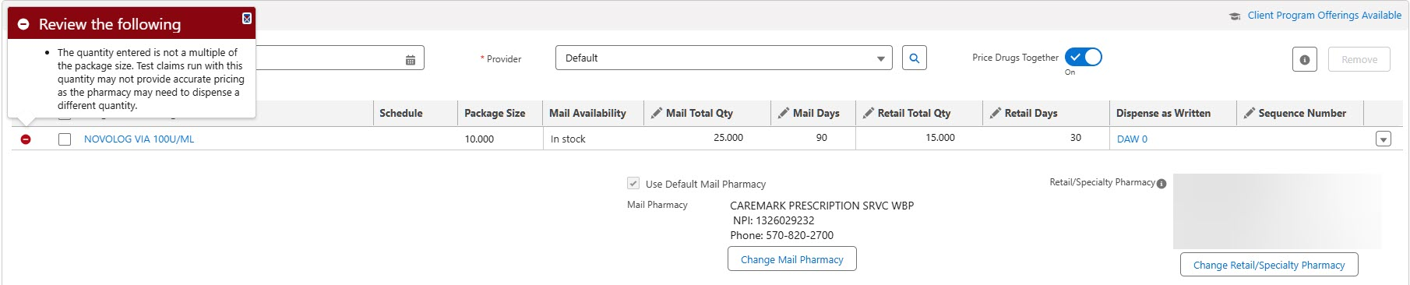

1. Click anywhere on the screen to close the message.

**Note:** This is not a hard stop. Proceed with the Test claim; however, pricing is not accurate.

Top of the Document

|  |
| --- |
| General Formula |

**Note:** For assistance in determining the below values, refer to [Calculating Quantities for Packaged Medication (028627)](https://thesource.cvshealth.com/nuxeo/thesource/#!/view?docid=7403e334-74ec-42c6-90fe-75aa0c93ca82) or [Compass - Calculating Quantity for Packaged & Non-Packaged Medications (050982).](https://thesource.cvshealth.com/nuxeo/thesource/#!/view?docid=fef7af0d-800c-49b2-9b3d-1831aef5ac2d)

|  |  |  |  |  |
| --- | --- | --- | --- | --- |
| **Units Per Day** | **X** | **Days** | **=** | **Units Needed** |

|  |  |  |  |  |
| --- | --- | --- | --- | --- |
| **Units Needed** | **÷** | **Usage Quantity Package** | **=** | **Total Packages Needed** |

|  |  |  |  |  |
| --- | --- | --- | --- | --- |
| **Total Packages Needed** | **X** | **Package Size** | **=** | **Test Claim Quantity** |

 Contact [Clinical Care Services (062778)](https://thesource.cvshealth.com/nuxeo/thesource/#!/view?docid=d2dab105-056c-45be-b28b-bfad61c60a2f) for assistance when:

* Usage **QTY Pkg** is **NOT** listed on the **Drug Details** screen in Compass and you are unsure of the quantity needed.

Top of the Document

|  |
| --- |
| General Formula Process |

Perform the steps below to run a Test claim for packaged medication:

 **DO NOT** use the following steps for Ointments, Creams, Grains or Liquids; refer to [Test Claim Calculating Quantity of Creams, Lotions and Ointments (045948)](https://thesource.cvshealth.com/nuxeo/thesource/#!/view?docid=219bea9b-0bf0-488b-8732-2345f3ec38c3) for further details.

|  |  |
| --- | --- |
| **Step** | **Action** |
| **1** | Determine how many total uses are needed per day.  **Example:** One eye drop in each eye once daily = 2 drops per day |
| **2** | Determine how many total uses are needed for the Day Supply.  **Example:** Caller is requesting price for a 3-month supply  2 drops per day X 90-day supply = 180 drops for a 90-Day Supply |
| **3** | Click on the **Drug hyperlink** for the specific strength of the medication. **Result:** The **Drug Details** screen displays. |
| **4** | Divide total uses needed for Day Supply by the **Usage Qty Pkg** and if result is not a whole number, then **round up**.  **Exception:** If result is not a whole number, then **round down** for Controlled Substances, Topical Agents, and Non-Diabetic Unbreakable Injectables.    **Example:** 180 drops / 37.5 = 4.8  If there is **NOT** a **Usage QTY Pkg** listed on the **Drug Details** screen, contact Clinical Care and they can inform you how many uses are contained within the packaged medication. |
| **5** | Multiply the total number of packages needed by the Package Size from the Drug Details.   |
| **6** | Enter the answer from **Step 5** as the Mail Total Qty for mail order price estimates or Retail Total Qty for retail Price Estimates. |

Top of the Document

|  |
| --- |
| Related Documents |

[MED D - Test Claim Index (021325)](https://thesource.cvshealth.com/nuxeo/thesource/" \l "!/view?docid=f20952af-741c-41d5-a343-6132374dfe64)

[Customer Care Abbreviations, Definitions, and Terms Index (017428)](https://thesource.cvshealth.com/nuxeo/thesource/" \l "!/view?docid=c1f1028b-e42c-4b4f-a4cf-cc0b42c91606)

**Parent Document:** CALL-0049: [Customer Care Internal and External Call Handling](https://policy.corp.cvscaremark.com/pnp/faces/DocRenderer?documentId=CALL-0049)

Top of the Document

Not To Be Reproduced Or Disclosed to Others Without Prior Written Approval

**ELECTRONIC DATA = OFFICIAL VERSION / PAPER COPY = INFORMATIONAL ONLY**